|  |
| --- |
| CAPSTONE PROJECT  Venue Recommendations to place a Mexican Restaurant |
|  |



**Introduction**

Due in part to business and immigration, United States has hispanic presence across several States, on which there is a widespread likability of Mexican food. In Addition, more traditional Mexican dishes have also grown in popularity in the United States,like tortillas, salsa, chips, chili, burritos, and tacos. Therefore, the intention of this project is to collect information and provide recommendations on potential places to place a Mexican restaurant based on statistical data, open sources and FourSquare API.

#### pROBLEM DESCRIPTION

Many Mexican people migrating to various states of United States would like to have traditional Mexican dishes near their location. The project aims to create an analysis of features for a place comparative analysis. The features include influence of Hispanic people, location near important venues and shopping malls. This would help decision makers to become aware of places of potential interest.

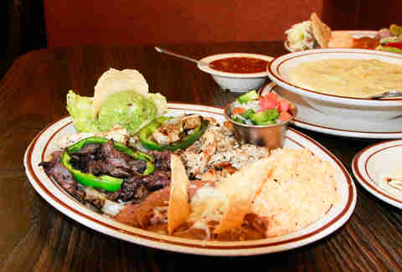

**Data Sources**

* For this business analysis we need to acquire geo-locational information about specific cities with a high influence of latin-american people, which have more likability of Mexican food.
* Census data of the United States Government already provides this information.
* The main point of interest of the stakeholders is the State of Maryland, as in they would have strategic Vendors on this State.
* In order to perform a comparison of the potential locations with a high venue and also potential competence nearby, we will use the Foursquare API. This dataset comprises latitude and longitude of landmarks, as well as ZIP Codes, which will be used as key to be cross-referenced with the other datasets.

#### DataSource 1

###### US Government Census Data

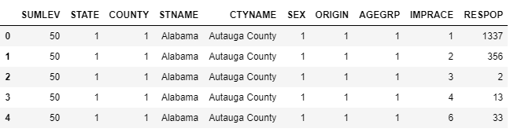

#### DataSource 2

Maryland Government Population Data

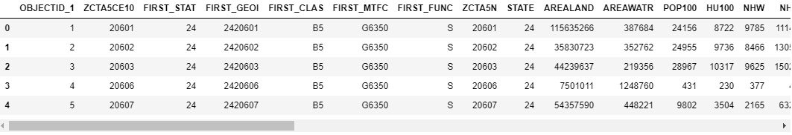

#### DataSource 3

###### Foursquare API Data

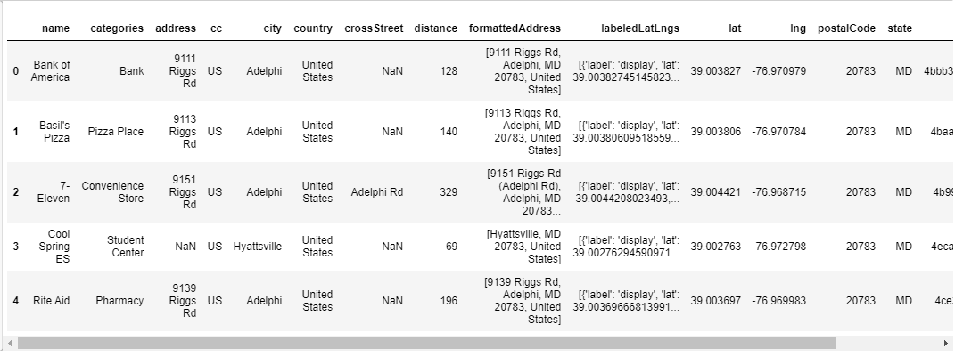

**Methodology**

Python Libraries used for the analysis:

* Pandas
* NumPy
* GeoPy
* Folium
* Matplotlib
* kMeans

Data source loading

* Path to the datasources.
* Census data of the United States Government:

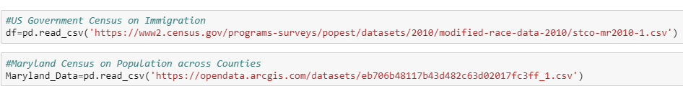

* As the main point of interest of the stakeholders is the State of Maryland, we have considered more details on this specific location.

Data Exploration

Filtering of the State of interest

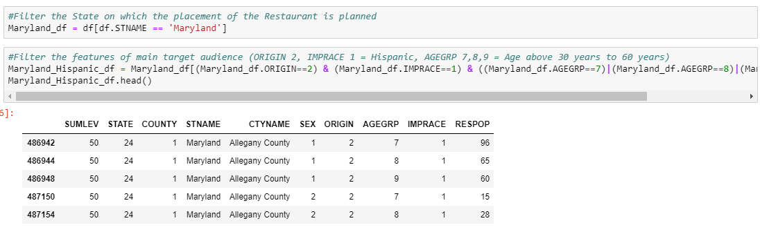

Perform Grouping of Relevant Counties by number of habitants and therefore review ZIP Codes with greather percentage of presence of Hispanics.

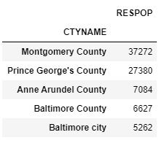

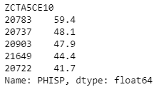

Data analysis

We filter the relevant ZIP Codes during the exploration phase, on which potentially the Restaurant can be placed:

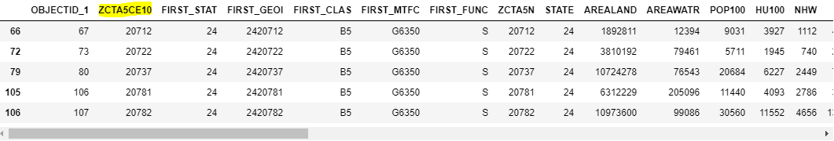

We evaluate the population number based on each ZIP Code:

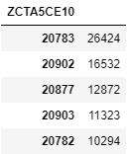

Based on the analysis of the Census Data, we have determined that our main target audience is Hispanic people between 30 and 59 years:

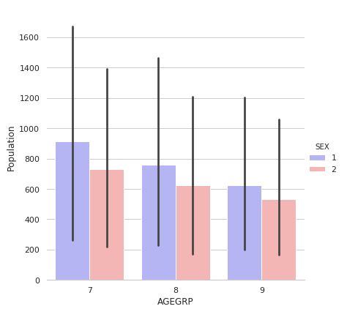

Group 7: 30-39 years

Group 8: 40-49 years

Group 9: 50-59 years

foursquare

Connecting to the Foursquare API in order to retrieve relevant information about the places located nearby, which helps to evaluate the venue relevance. According to the Data Analysis on the Census Data and exploration of locations. The city of ‘**Adelphi, MD**’ is of potential interest.

After finding the neighborhood of interest, we then connect to the Foursquare API to gather information about landmarks of interest on a radius of 500 meter.

One of the most relevant points of interest are the shopping malls nearby:

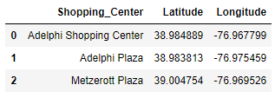

clustering

We prepare the data for clustering based on categories and closeness of relevant landmarks:

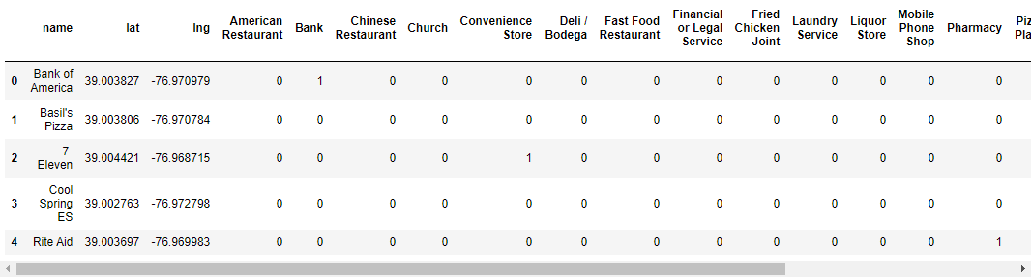

Then we apply the k-Means Clustering method, selecting 5 clusters and we append the result to the DataFrame:

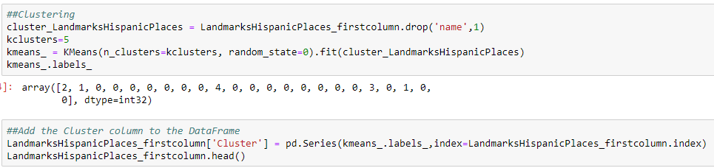

**Results**

#### Maps generated with folium based on fourquare api and data sources

###### Strategic Shopping Malls Nearby

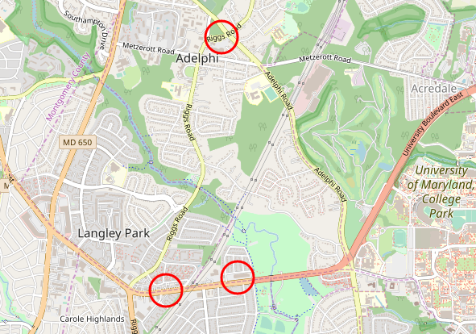



###### Relevant Landmarks near Adelphi City Center

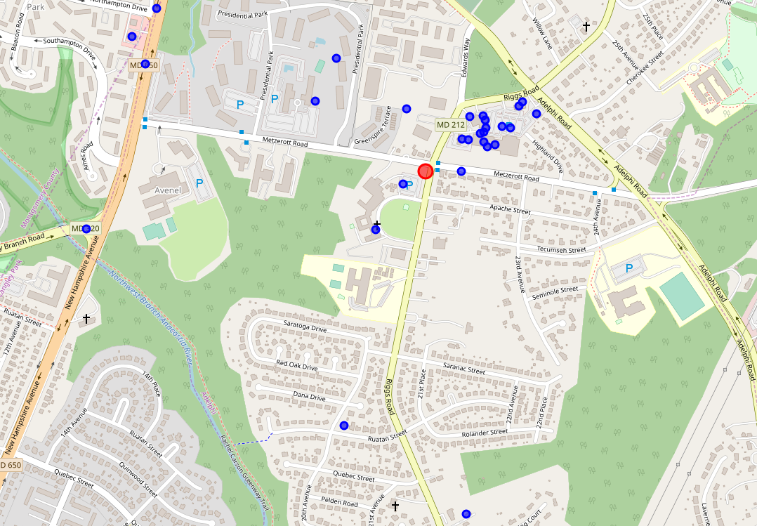

###### Clustering of relevant venues near Metzerott Plaza

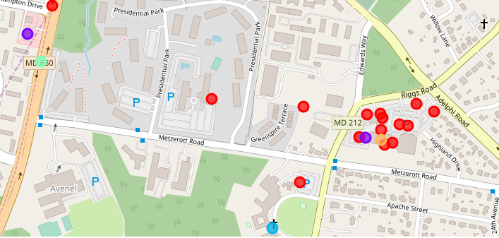

**Conclusion**

The city of Adelphi, MD, with a population of almost 60% of latinamerican people. Represents a good opportunity to place a Mexican Restaurant.

Based on Foursquare data, only one Mexican Restaurant was located called ‘*Los Antojitos*’. Therefore, a new Restaurant would represent an opportunity based on the potential demand for traditional dishes.

Based on clustering, we have identified two potential places near strategic Shopping Malls, which represent a higher concurrence of people.

